**Azure Dev ops Project Assignment**

**Name: S. Nikhil Sai**

**Date: 11-12-2024**

Steps to Create an Epic in Azure Boards:

1. Access Azure Boards
   * Log in to your azure dev ops account.
   * Navigate to the project where you want to create the Epic.
2. Go to the Work Items Section
   * From the left-hand menu, select Boards > Work Items.
   * Alternatively, you can go to Boards > Backlogs.
3. Select the Epic Work Item Type
   * If you’re in the **Work Items** view:
     + Click the **New Work Item** dropdown at the top.
     + Select **Epic** from the list.

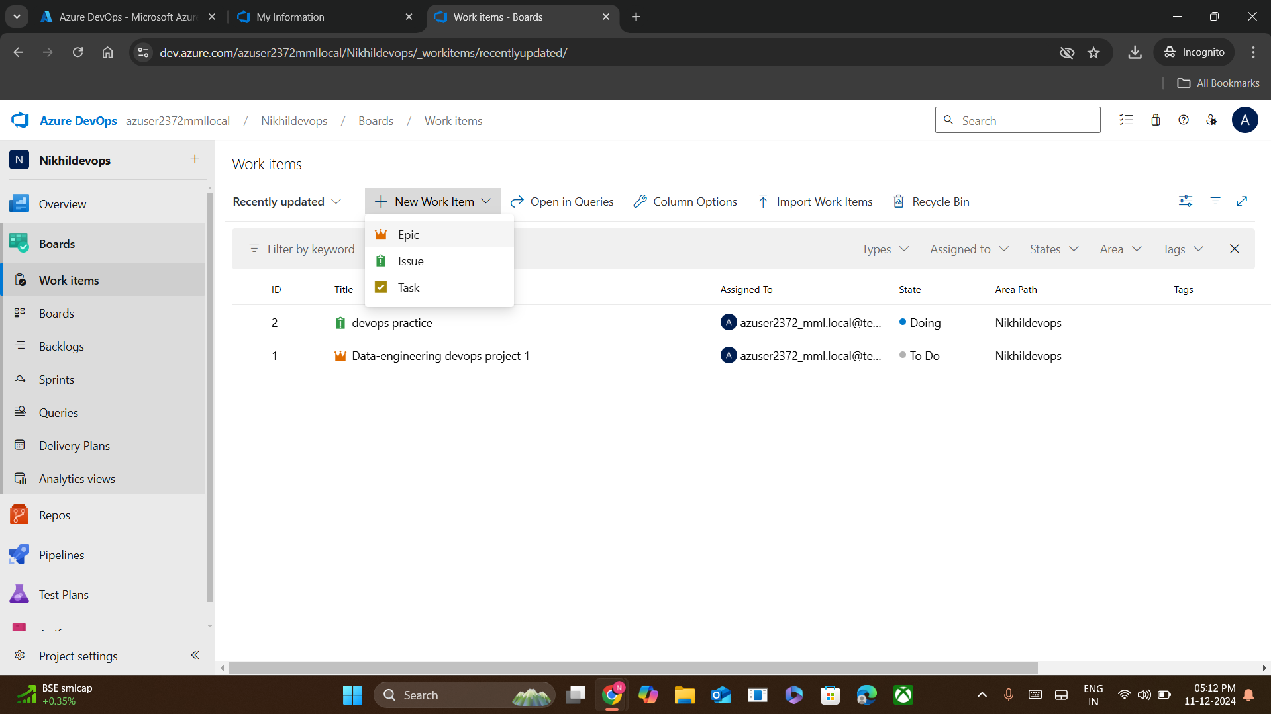

1. **Fill in Epic Details**
   * **Title**: Enter a meaningful title for the Epic.
   * **Description**: Provide a detailed description of the Epic, outlining its goals and purpose.
   * **Acceptance Criteria**: Add criteria that define when the Epic is complete (optional but recommended).
   * **Tags**: Add relevant tags to help categorize and search for the Epic later (optional).
   * **Priority/State**: Set the priority and initial state (e.g., New).
   * A screenshot of a computer

     Description automatically generated
2. **Assign the Epic**
   * In the **Assigned To** field, assign the Epic to a team member or leave it unassigned for now.
3. **Save the Epic**
   * Click **Save & Close** to save the Epic and exit the editor.
   * Alternatively, click **Save** to save changes and continue editing.

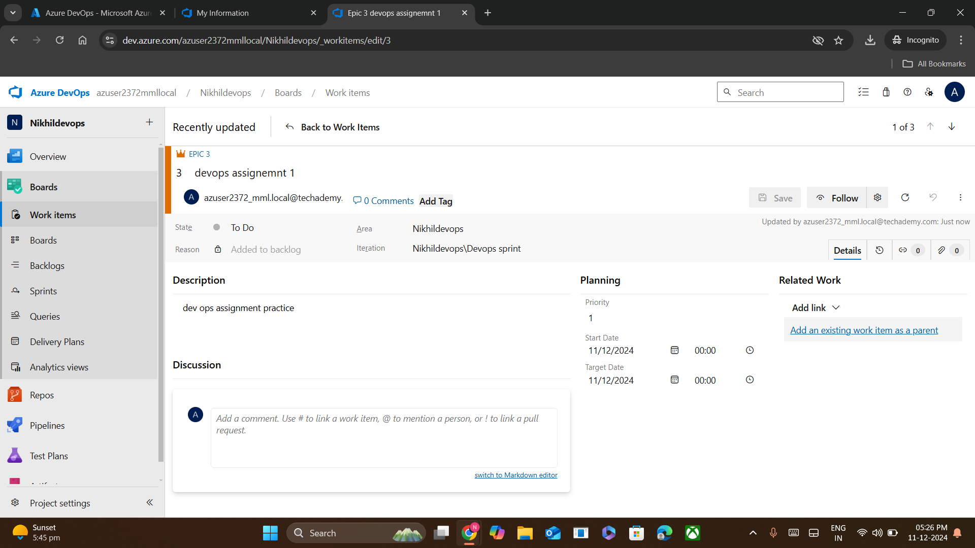

1. **View the Epic in Backlog**
   * Navigate to **Boards** > **Backlogs** and ensure you’ve selected the **Epics** level.
   * The newly created Epic should now be visible.

